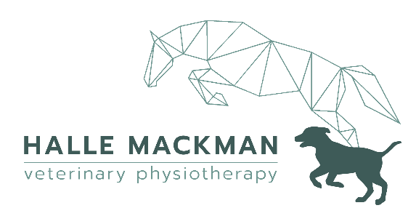
owner’s permission to treat
Tel. 07734251059
Web. www.hallevetphysio.com
Email. info@hallevetphysio.com

Owner Details |  | Veterinarian Details
Name |  | Practice Name
Telephone |  | Telephone
Email |  | Email
Address |  | Practice Address
Patient Details
Name |  |  | Age |  | Sex
Species |  |  | Breed
Reason for Treatment
Clinical History
Current Medication
Owner Declaration
By signing, I consent for my animal to receive maintenance physiotherapy from Halle Mackman. I understand that my animal may be referred back to the veterinarian, and treatment will stop if the physio has any concerns.
Owner’s Signature
Date

Halle Mackman Veterinary Physiotherapy
Tel. 07734251059
info@hallevetphysio.com

