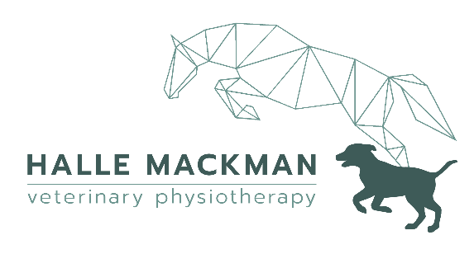
Tel. 07734251059
Web. www.hallevetphysio.com
Email. info@hallevetphysio.com

veterinary consent form

Owner Details |  | Veterinarian Details
Name |  | Name
Telephone |  | Telephone
Email |  | Email
Address |  | Practice Address

Patient Details
Name |  |  | Age |  | Sex
Species |  |  | Breed
Clinical History
Current Medication
Precautions
Additional Notes
Veterinary Consent
By signing, I consent for this animal to receive physiotherapy from Halle Mackman.
Veterinarian Name
Veterinarian Signature
Date


Kind Regards,

Halle Mackman
BSc Equine Sports Science | MSc Veterinary Physiotherapy | AHPR Registered | MNAVP

